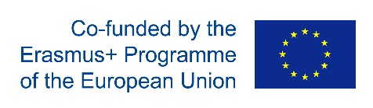
TRAVEL PLAN
ECOIMPACT Project

The completed form shall be submitted to Project Manager via e-mail (svyatoslav.tyuryakov@fmi.fi).
Travel expenses are eligible only after the travel is authorised by Coordinator.

Name
Date of birth
Home institution and department
Staff position/Student year of study
E-mail
Telephone

Destination
(institution, town, country)
Travel start  (date and time) |  | Travel end  (date and time)
Purpose of travel

Authorised by Project Coordinator
Date: ……………..………... | Signature: …….………………………..……………

